PCA Lunch Menu for May 2021
Please return to the office by April 21st Name Grade
Sunday | Monday | Tuesday | Wednesday | Thursday | Friday | Saturday
 |  |  |  |  |  | 1
 | 3 | 4 | 5 | 6 | 7 | 8
 | Chicken Patty X  Corn  Pears M | Taco in a bag X  Lettuce/Cheese  Salsa/Sour Cream  Pineapple M | Hot Dog X  Chips  Peaches M | Pizza Hut X  Green Beans  Applesauce M | Pancake Wrap X  Hash brown  String Cheese  Yogurt M
 | 10 | 11 | 12 | 13 | 14 | 15
 | Fish Sandwich X  Chips  Pudding M | Cheese Quesadilla X  Spanish Rice  Strawberries M | Corn Dog X  Mac & Cheese  Applesauce M | Godfather’s Pizza X  Carrots  Peaches M | French Toast Sticks X  Sausage  Yogurt M
 | 17 | 18 | 19 | 20 | 21 | 22
 | Taquitos X  Spanish Rice  Pineapple M | Sloppy Joe X  Hash brown  Pudding M | Chicken Nuggets X  Tater Tots  Pears M | Pizza Hut X  Corn  Applesauce M | Noon Dismissal
 |  |  |  |  |  | 29
 | Enjoy | Summer | Break!
 | 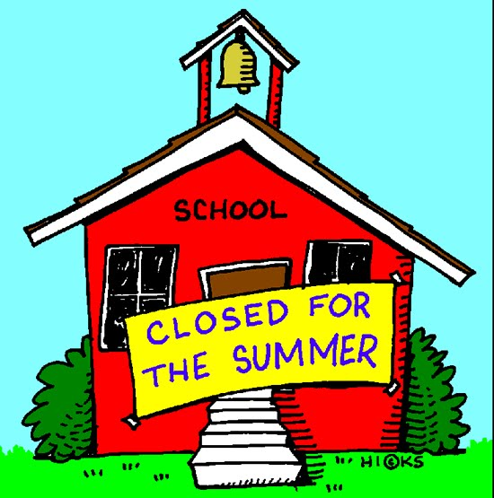 | Notes:  Credit of $___________________________ Lunches___________ @ $2.75 = $_________________  Charge of $_________________________ Extras_____________ @ $1.00 = $_________________  Milk ______________ @ $0.30 = $_________________  Total = $_________________

